**Local Deployment**

Local deployment requires a few steps:

1. In order to run our application, an HTTP web server must be installed on your system. For our local deployment we used Apache HTTP 2.4 (<http://httpd.apache.org/docs/2.4/>). Download and installation instructions, per your specific environment, can be found at <http://httpd.apache.org/download.cgi#apache24>.
   * For Windows, Apache 2.4 binaries VC14 at <http://www.apachelounge.com/download/> is recommended for use, as it has been tested by our team.

Of course, other web server installations can be used, allowing for versatility across many environments. For example, NPM package manager provides a simple zero-configuration command-line http server.

npm install http-server -g

1. Clone the repository at <https://github.com/akulasainath/18frepo.git>, using the desired branch.

git clone <https://github.com/akulasainath/18frepo.git>

The repository can also be download directly from any internet browser: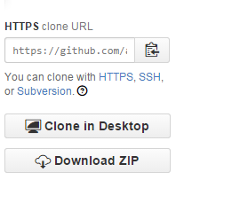

1. Move the entire /18FDemo/web directory of the cloned repository to the /htdocs directory (Apache), or the default configured directory, of your HTTP web server installation directory.
2. Start the HTTP web server. Apache instructions can be found at <http://httpd.apache.org/docs/2.4/invoking.html>.
3. If deployed correctly using the default Apache configuration settings, the application should be available at: <http://localhost:80/web/>